In our Heidegger discussion of last class, the point was made about how he emphasizes thinking and language as active, living, on-going, and thus you have to “walk with him” to understand him. Similarly, this course from its beginning until now we have been trying to “walk toward” Heidegger. This handout retraces our “walking route” as a quick review, and to connect course to Heidegger.
Historically, modern science emerges as a revolt (Copernican or scientific revolution) against the medieval, western Christian, theological, worldview, rejecting the Great Chain of Being, geocentrism, teleological explanation, and a spiritually-pervaded cosmos, for instead a “disenchanted universe”: a conception of Nature as Objective Reality that was reductionist, heliocentric, mechanistic, measure-able, mathematic. Based on this conception, we realize the universe to be far deeper than tradition had realized: deep space, deep time, deep process. Modern science reaches its high point in the last decades of the 1800s (when the university system is founded and universal education in schools implemented).
O
Positivism → logical positivism → Popper focused on:
-understands issue to be rationality, theory, logic, of how objectivity is thought
-defense of established conception of objectivity. Ignores, overlooks, and proves to assume a very “disembodied” subjectivity

Post-positivism: A reversal of “objective” focus: the O presupposes an S. S → O relation is crucial

Therefore, the overlooked depths of subjectivity (S) in constituting objectivity (O) begin to appear
S → 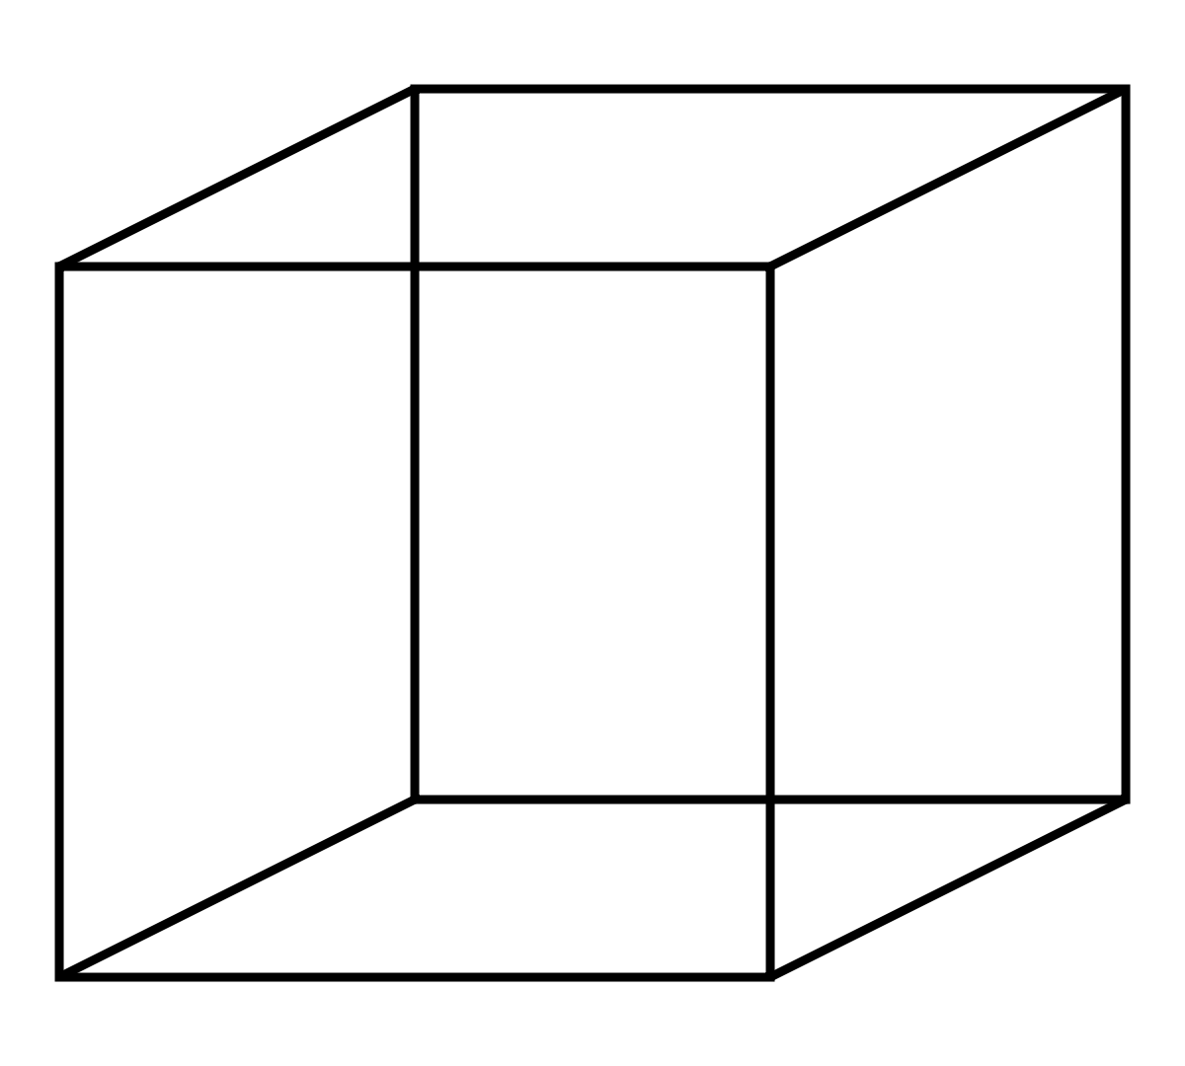 ← S ( O )
( O )

Kuhn: -objectivity is paradigm-relative
object perceive-able differently
-the S → O relation problematized (but retained)
-notion of paradigm highlights the sociological and cognitive
(the “deep social”) component of subjectivity

Polanyi: -objectivity is personal; “commitment-relative”
S → O relation (focal awareness)
occurs within a horizon of broader consciousness (subsidiary awareness, tacit knowing)
-objectivity is contact with reality (commitment, yes,
but not arbitrary, reality multi-focal, many-levelled)
-consciousness irreducible to S → O relation (in effect
rejects the S → O conception of reality; “horizonal”)
-notion of tacit highlights the experiential and existential
(the “deep personal”) component of subjectivity

Heidegger: - S → O an artefact of a particular language, tradition, and metaphysics (post-Greek)
-deep objectivity (of space, time, process) or deep subjectivity (of the social, cognitive, experiential, existential) give way to a deeper mode of understanding
-different “languagings” of Being disclose or open different modes of truth
(Nope, not
picture-able!)
-these are ultimately (deeply?) always within an “epochal” understanding
-“epochal” understandings are carried on historically by a tradition,
but they are more than just historical or traditional – (“epochal, destiny-al ?”)

